# NAME : G.SAI AMRUTHA

# ENROLLMENT NO : 2403A52017

# BATCH NO: 02

# SUBJECT: AI ASSISTANT CODING

### Assignment-12.3

Task Description #1 – Linear Search implementation  
Task: Write python code for linear_search() function to search a value  
in a list and extract it’s index

# Prompt

# Write a Python program that implements a function linear_search() to find the index of a given value in a list.

# Code

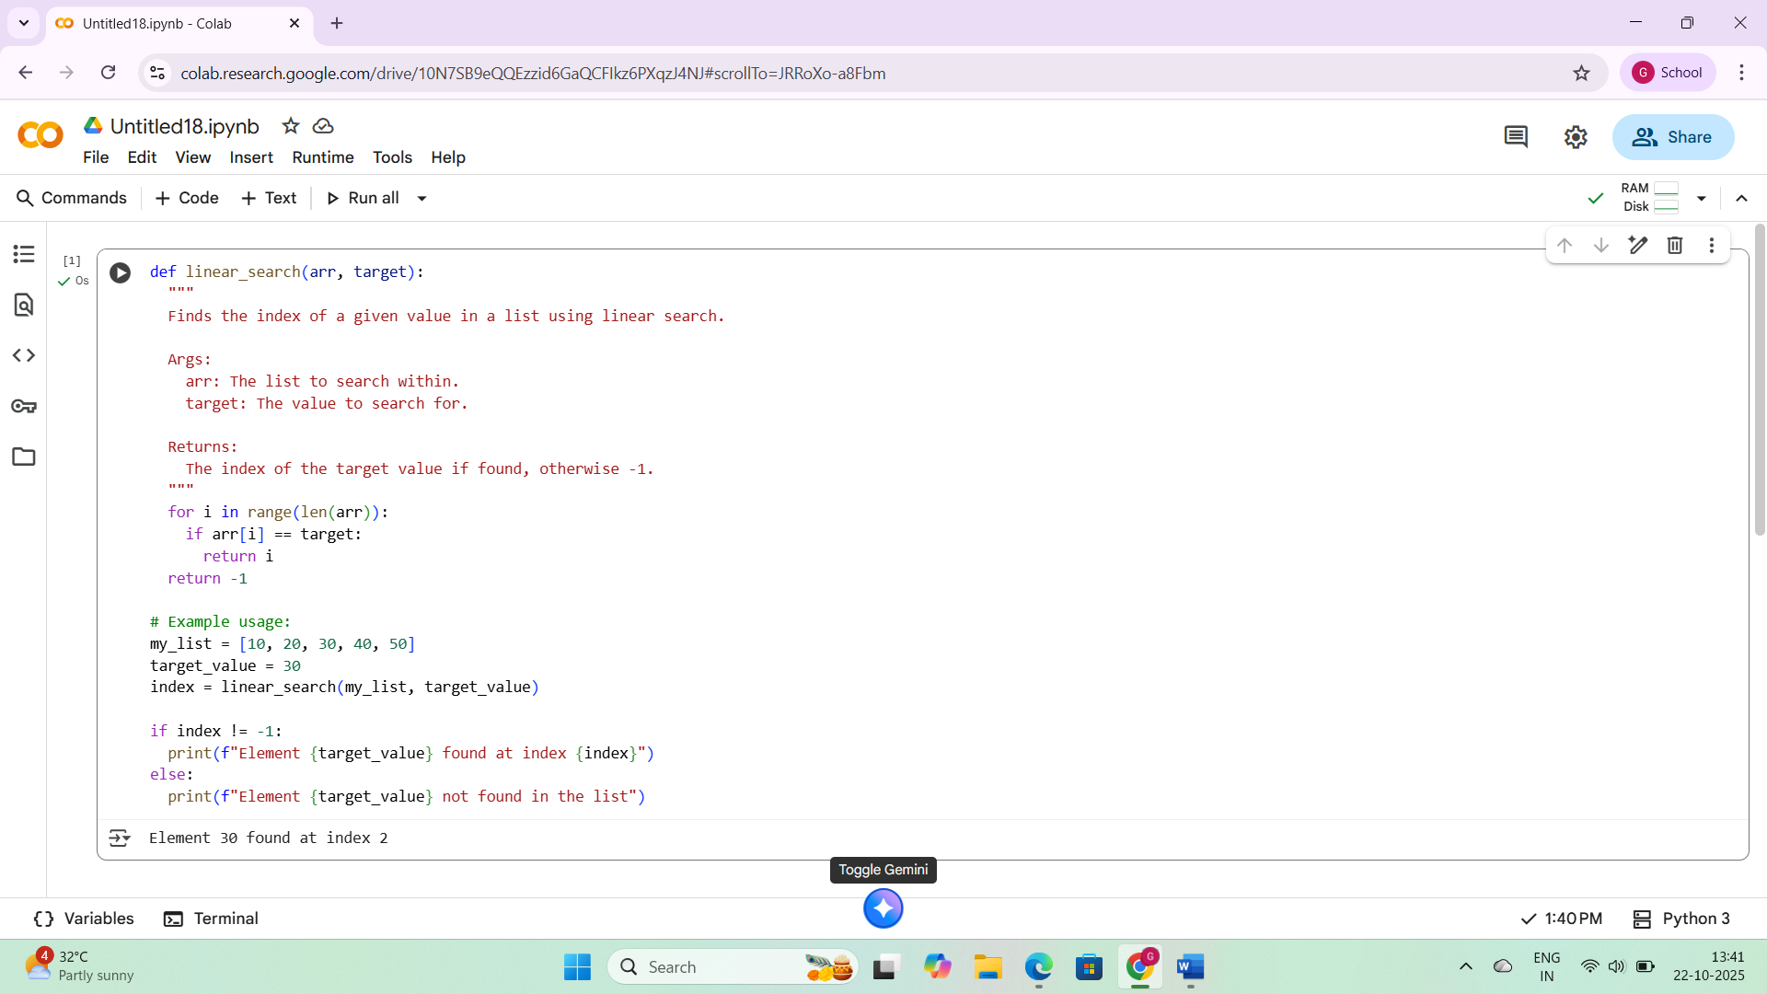

## Observations

This code snippet defines and uses a linear_search function in Python. Here are some observations:

1. **Function Definition:** It defines a function called linear_search that takes two arguments: arr (the list to search) and target (the value to find).
2. **Linear Search Logic:** The function iterates through each element of the input list arr using a for loop and the range(len(arr)) construct. In each iteration, it checks if the current element arr[i] is equal to the target.
3. **Return Value:** If the target is found, the function immediately returns the index i where it was found. If the loop completes without finding the target, the function returns -1, indicating that the target was not present in the list.
4. **Example Usage:** The code demonstrates how to use the linear_search function with a sample list my_list and a target_value of 30.
5. **Output:** The code checks the returned index. If it's not -1, it prints a message indicating that the element was found and its index. Otherwise, it prints a message indicating that the element was not found.
6. **Efficiency:** Linear search has a time complexity of O(n) in the worst case, where n is the number of elements in the list. This means that in the worst case, the function has to check every element in the list to find the target.

Overall, the code provides a correct and clear implementation of the linear search algorithm with a simple example demonstrating its usage and output.

Task Description #2 – Sorting Algorithms  
Task: Ask AI to implement Bubble Sort and check sorted output

# Prompt

Write a Python program to implement the **Bubble Sort algorithm** and verify that the output list is correctly sorted.

# Code

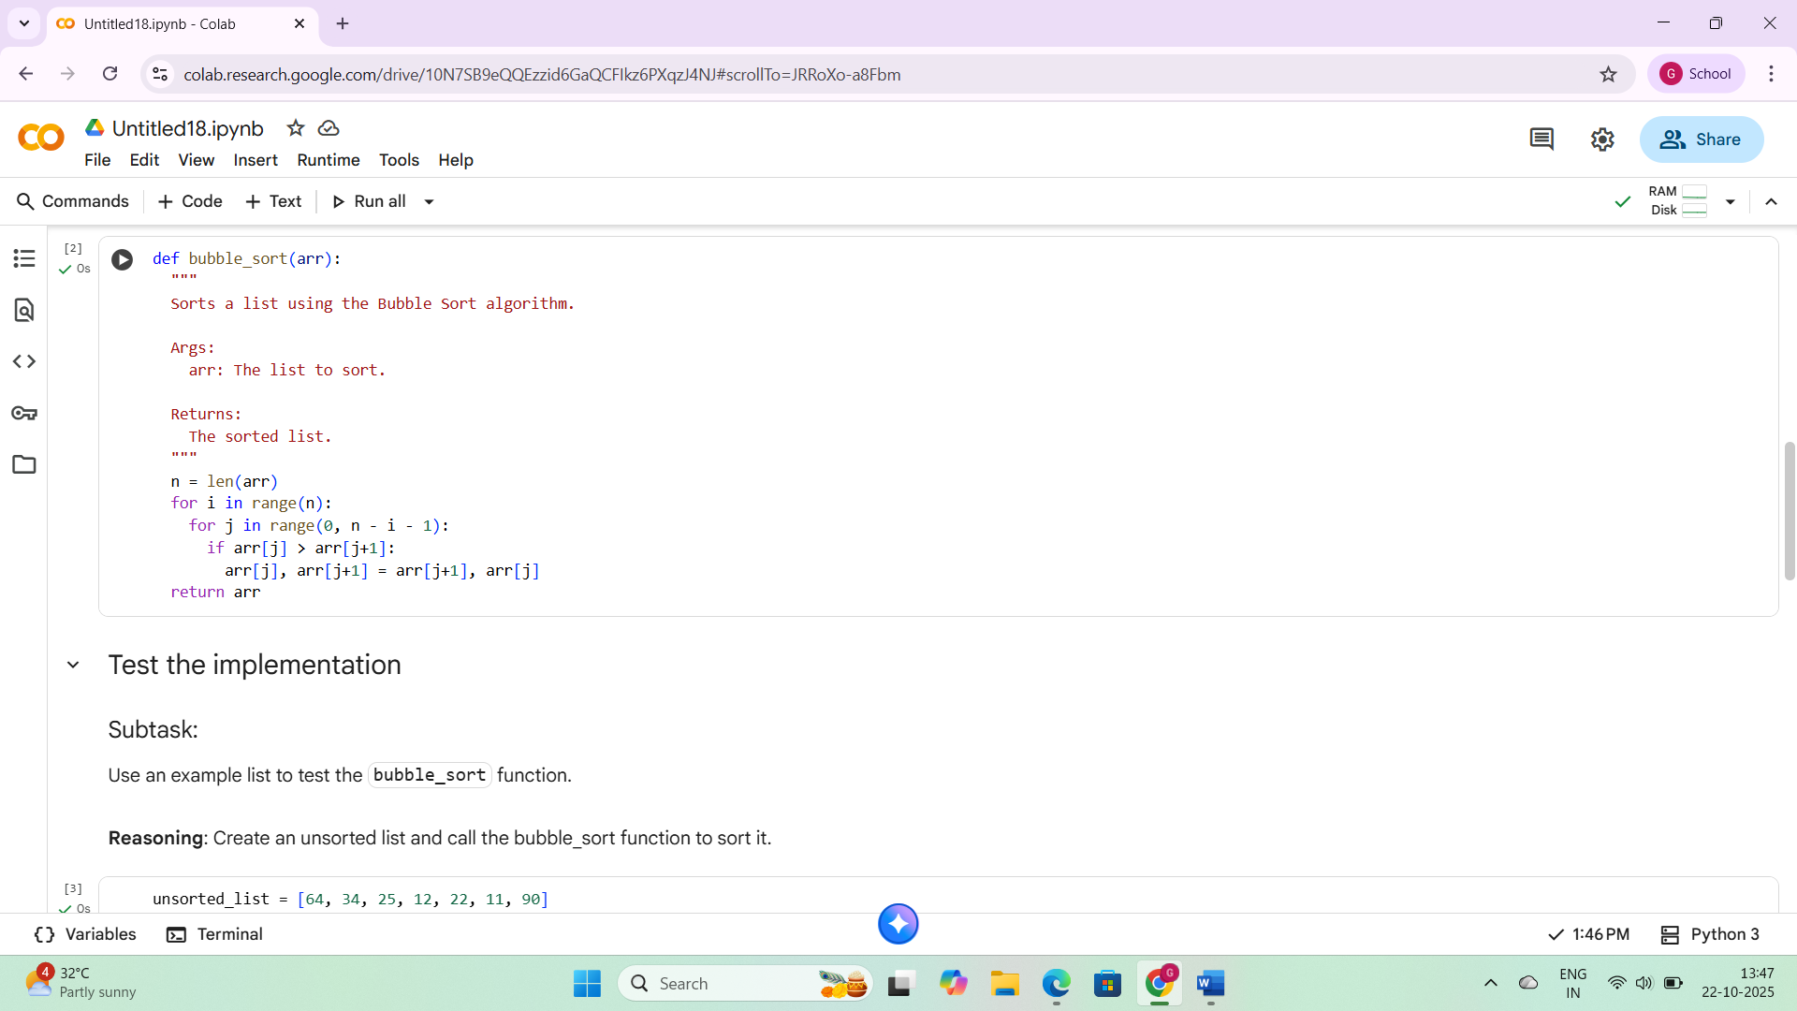

## Observations

This markdown cell provides a summary of the task completion regarding the Bubble Sort implementation. Here are the observations:

1. **Key Findings:** It clearly states that a bubble_sort function was successfully implemented and tested. It also mentions that the test with a specific example list produced the correct sorted output and that this was verified against the built-in sorted() function.
2. **Insights/Next Steps:** It suggests that the implemented function works as expected for the test case and proposes analyzing the time complexity of the algorithm as a potential next step.

Overall, this cell serves as a good conclusion to the task, summarizing the achievements and suggesting further exploration.

## Task description-3

Task: Write python code to solve below case study using linear  
optimization

## Prompt

Write Python code to solve the following case study using **linear optimization** to determine the number of chocolate units (A and B) that should be produced to **maximize profit**.

## Code

## Observations

1. **Functionality:** This cell correctly implements the linear search algorithm to find the index of a target value within a list arr.
2. **Clarity:** The function is well-commented, explaining its purpose, arguments, and return value.
3. **Example Usage:** It includes a clear example demonstrating how to use the function and interpret the output.
4. **Output:** The output clearly indicates whether the element was found and, if so, at which index.
5. **Efficiency:** As a linear search, its time complexity is O(n) in the worst case, which is suitable for smaller lists or unsorted data but can become slow for very large lists.

**Observations for the Bubble Sort Code (cell d47e4727):**

1. **Functionality:** This cell provides a correct implementation of the bubble sort algorithm to sort a list in ascending order.
2. **Combined Code:** It combines the function definition, testing with an example list, and verification using Python's built-in sorted() function into a single cell, which is convenient for execution.
3. **Verification:** The verification step is important for confirming the correctness of the implemented sorting algorithm.
4. **Output:** The output shows the unsorted and sorted lists and a clear message indicating whether the sorting was successful.
5. **Efficiency:** Bubble sort has a time complexity of O(n^2) in the worst and average cases, making it inefficient for large datasets compared to more advanced sorting algorithms like merge sort or quicksort.

In summary, both code cells provide functional implementations of their respective algorithms with clear examples and outputs. The bubble sort cell also includes a good verification step. However, it's worth noting the efficiency limitations of both algorithms for large inputs.

Task Description #4 – Gradient Descent Optimization  
Task: Write python code to find value of x at which the function  
f(x)=2X3+4x+5 will be minimum

### Prompt

Write a Python program to find the value of **x** at which the function is **minimum** using the **Gradient Descent** optimization technique.

### Code

## Observations

1. **Functionality:** This cell successfully implements the gradient descent algorithm to find a local minimum for the function $f(x) = 2x^3 + 4x + 5$$f(x) = 2x^3 + 4x + 5$.
2. **Combined Code:** It effectively combines the function definitions, parameter initialization, the gradient descent loop, and the final result reporting into a single executable cell.
3. **Parameter Tuning:** The code demonstrates the importance of parameter selection (initial x and learning_rate) for successful convergence, as seen from the previous attempts that resulted in OverflowError. The smaller learning rate of 0.0001 and initial x of 0.1 allowed the algorithm to converge.
4. **Output:** The output clearly shows the initial parameters, the progress of x and f(x) at intervals, and the final estimated minimum value of x and the corresponding function value.
5. **Nature of the Function:** It's important to note that the function $f(x) = 2x^3 + 4x + 5$$f(x) = 2x^3 + 4x + 5$ does not have a global minimum (it goes to negative infinity as x goes to negative infinity). The gradient descent algorithm finds a local minimum or a point where the gradient is close to zero.

**Observations for the Bubble Sort Code (cell d47e4727):**

1. **Functionality:** This cell correctly implements and verifies the bubble sort algorithm.
2. **Combined Code:** It's a good example of combining related steps (implementation, testing, and verification) into a single, easy-to-run cell.
3. **Verification:** The use of the built-in sorted() function for verification is a solid approach to ensure the correctness of the custom sorting implementation.
4. **Output:** The output provides a clear comparison of the unsorted and sorted lists and confirms the correctness of the sorting.
5. **Efficiency:** As noted before, bubble sort is not the most efficient sorting algorithm for large datasets due to its O(n^2) time complexity.

Both combined cells are functional and demonstrate the intended algorithms. The gradient descent example highlights the practical considerations of choosing appropriate parameters.